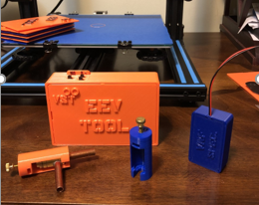

**ST-01 EEV Tool Directions:**

**Step 1: Remove the cover with a small pocket screw driver using the slot provided on one of the ends.**

**Step 2: Install the batteries. Before proceeding verify they are properly installed as reversing the positive and negative terminals can result in damage to the PCB.**

**Step 3: Verify the power switch is in the “off” position then plug the power assembly (stepper motor) into the connector shown. Plugging in the motor when the tool is powered on can result in damage to the PCB**

**Step 4: Switch the tool to the ON position and watch the shaft direction. While using the tool to drive the motor in either direction, watch the motor shaft to ensure both CW and CCW operations are normal. When the motor is driven to the fully open or fully closed position, a noticeable vibration can be felt as the motor has stalled.**

**Prior to re-installing the motor, the tool should be used to drive the motor shaft to the fully open position. Doing so ensures the stepper valve position steps (pulses) and the ODU command are the same (calibrated).**

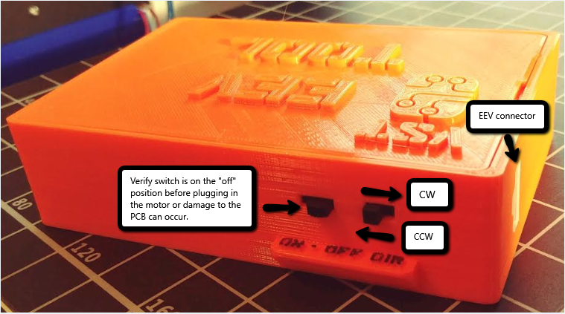

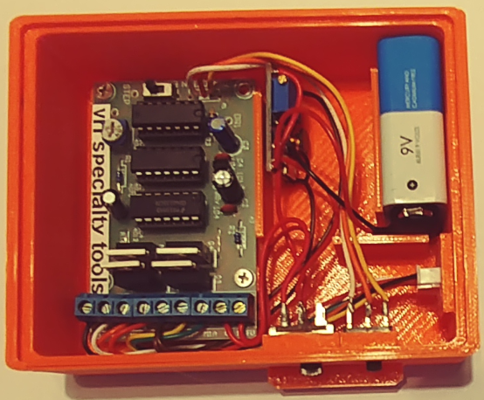

**EEV Tool Patent Pending #62/823,479**

**ST-01 EEV Tool notes:**

**\* This EEV tool should only be used by qualified technicians who have been properly trained for troubleshooting and repairing VRF equipment.**

**VRF Specialty Tools assumes no liability for damage to the equipment, or the tool itself, as a result of improper use of the tool and/or failure to verify normal equipment operation after the tool has been used.**

**\*\* To know with 100% certainty the position of the stepper motor shaft, the motor assembly must be removed from the EEV body. Prior to removing the motor, the system should be placed in the service function mode that drives the EEV to the fully open position. At that time the power assembly can be removed.**

**Although it is possible to use the tool to drive the EEV motor to the fully open or fully closed position without removing it from the valve body, the fact that the motor is stalled (noticeably vibrates) is not verification the motor is truly either open or closed. A damaged gear can stall the motor resulting in the same vibration regardless of the actual motor position. It is for this reason it is recommended to always remove the stepper motor and verify what the motor shaft is actually doing.**

**\*\*\* Make sure to keep the tool dry. Water or moisture will damage the tool causing it to fail and void warranty.**

.

**Limited Warranty:**

**Thank you for your purchase. All items sold by VRF Specialty Tools are warranted for 1 year from the date shipped. Warranty does not cover obvious physical damage from mishandling or exposure to water.**

**To obtain warranty please fill out the information below and email to** [**bld529.vst@gmail.com**](mailto:bld529.vst@gmail.com)**.**

**Name__________________________________________________**

**Address________________________________________________**

**City, State, Zip___________________________________________**

**Item #_______________________**

**Date Purchased_______________**

**Issue___________________________________________________**

**_______________________________________________________**

**Troubleshooting:**

**Step 1- * Connect stepper motor to EEV Tool and set power switch to on,**

**Step 2- Verify 9 vdc between KitV and GND,**

**Step 3- Verify 12 vdc between V+ and GND GND.**

**If 9 vdc is not present between KitV and GND or 12 vdc is not present between V+ and GND, check the batteries, the power switch and the wiring. If power is normal, proceed to step 4.**

**Step 4- Check the direction switch. The direction switch is a SPDT switch. To check it, power off the EEV tool and unplug the motor. When the switch is moved to the right, the center and RH terminals should have continuity. When the switch is moved to the left, the center and LH terminals should have continuity.**

**Step 5- Turn the potentiometer CW until it stops,**

**Step 6- Very slowly turn the potentiometer CCW and watch the stepper motor shaft. Once motor shaft starts to rotate, continue slowly turning the potentiometer CCW until the smoothest rotation is achieved. Check rotation in both directions. Adjust potentiometer so that the motor drives in both directions.**

**NOTE: If the potentiometer is rotated too far after the stepper motor starts to rotate, it will stop again. If this happens, turn the potentiometer CW again and repeat process.**

**The rotation switch is a SPDT switch. To check, power off the EEV tool. When switch is moved to the right the center and RH terminals should have continuity. When the switch is moved to the left, the center and LH terminals should have continuity.**

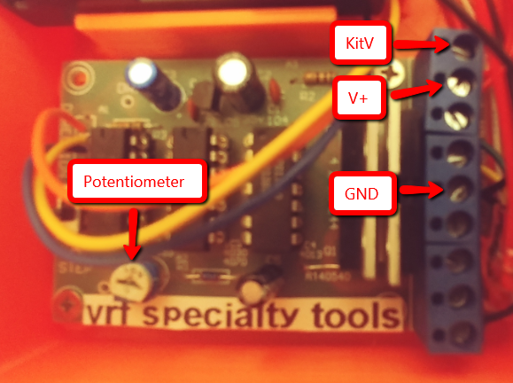

**\* Always plug motor in to EEV Tool before powering on or damage to the PCB can occur.**

**Checking / Setting Regulator Output Voltage on ST-01 EEV Tool**

**For optimum results when using the EEV Tool to drive 12 vdc stepper motors, the voltage regulator output needs to be between 12 vdc – 13 vdc. Lower output voltages can result in erratic operation. The following steps provide directions on where to measure the output voltage and how to adjust if necessary.**

**1- Turn the On/Off switch to the Off position.**

**2- Set meter to DC voltage and measure the regulator output voltage at A (positive lead) and B (negative lead) as noted by the red arrows on the adjacent diagram.**

**3- Use the adjustment screw as shown in the pictures to adjust the output voltage. CW to increase voltage, CCW to decrease it.**

**4- Start with ½ turn increments and re-measure voltage after each adjustment. Once the output voltage starts to change, reduce to ¼ turn increments.**

**5- Continue adjusting until an output voltage of between 12 vdc and 13 vdc is obtained.**

**Note: It may take several turns before the voltage starts to change. This is normal. By keeping the adjustments to small increments, the possibility of over-adjusting the potentiometer is decreased.**

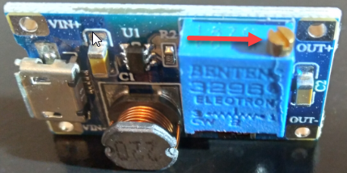

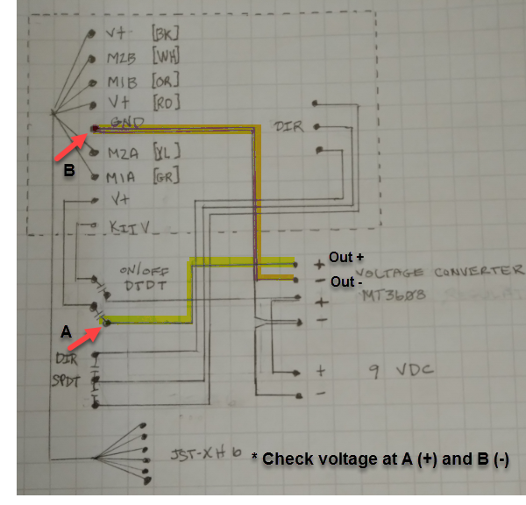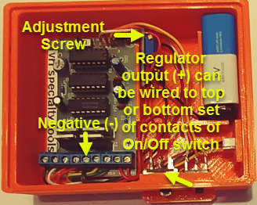



**ST-02 Transducer Tool Directions:**

**The ST-02 Transducer Tool is used for LG 0-5 vdc pressure for the following purposes:**

**a-Uses 3 vdc to verify PCB pressure transducer readings.**

1. **On multi-chassis systems, enables a constant pressure reading to be inputted on a leaking ODU after it has been isolated from the system, allowing the system to operate.**

**Step 1: Remove the cover with a small pocket screw driver using the slot provided on one of the ends.**

**Step 2: Install 2ea AA batteries. Before proceeding, verify they are properly installed as reversing the positive and negative terminals may result in damage to ODU PCB. Using a good quality volt meter, measure the DC voltage on the tool’s male connector. Depending on battery strength, the voltage should be approximately 3 VDC.**

**Step 3: Power off the ODU and unplug the HP and LP transducers. Verify the GND wire on the tool is in the same location as the GND wire on the ODU transducer wire harness and the positive wire, 3 VDC +/-, on the tool is in the same location as the signal wire on the ODU transducer wire harness.**

**Step 4: Plug in the transducer tools to the HP and LP connectors on the ODU PCB and power up the ODU.**

**Step 5: Use the signal voltage/pressure chart for the ODU to calculate the HP and LP for the measured voltage from step 2.**

**Step 6a: If the tools were installed to provide pressure on an ODU with a refrigerant leak, the ODU can now be isolated and placed in backup (non-operating) mode.**

**Step 6b: Compare the calculated voltage, with the voltage displaying on the service software program. Replace ODU if pressure readings are significantly different and calculated voltage has been rechecked and verified. Keep in mind the same voltage input on HP and LP terminals, does not normally result in the same pressure readings.**

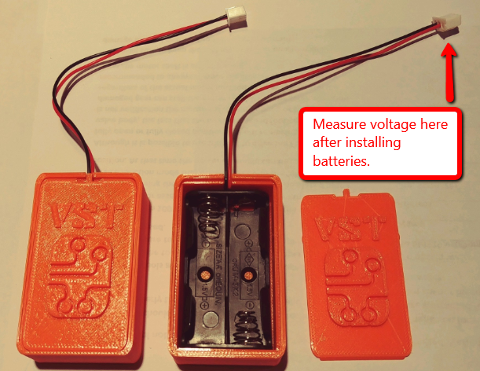

**Typical signal voltage/pressure chart. Only use the chart for thee specific ODU being repaired.**

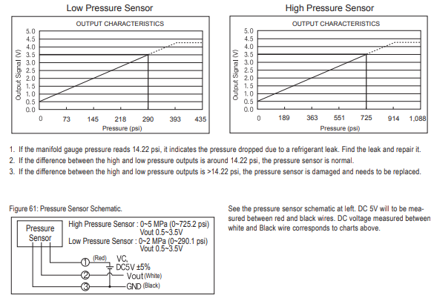

**ST-02 Transducer Tool notes:**

**\* This transducer tool should only be used by qualified technicians who have been properly trained for troubleshooting and repairing VRF equipment.**

**VRF Specialty Tools assumes no liability for damage to the equipment, or the tool itself, as a result of improper use of the tool and/or failure to verify normal equipment operation after the tool has been used.**

**\*\* Make sure to keep the tool dry. Water or moisture will damage the tool causing it to fail and void warranty.**

.**Limited Warranty:**

**Thank you for your purchase. All items sold by VRF Specialty Tools are warranted for 1 year from the date shipped. Warranty does not cover obvious physical damage from mishandling or exposure to water.**

**To obtain warranty please fill out the information below and email to** [**bld529.vst@gmail.com**](mailto:bld529.vst@gmail.com)**.**

**Name__________________________________________________**

**Address________________________________________________**

**City, State, Zip___________________________________________**

**Item #_______________________**

**Date Purchased_______________**

**Issue___________________________________________________**

**_______________________________________________________**



**ST-03 / ST05 EEV Block-off Tool Directions:**

**The ST-03 EEV Block-off Tool is used to temporarily replace a damaged or non-functioning EEV stepper motor in an IDU or HR box. The ST-03 tool closes the EEV, thus preventing refrigerant flood-back thereby allowing the system to continue to operate until the failed EEV stepper motor can be replaced.**

**Step 1: Place the system in the service function mode that drives all EEVs to the fully open position.**

**Step 2: Remove the existing stepper motor.**

**Step 3: Install the ST-03 EEV Block-off Tool. Verify the pointed tip of the brass thumb screw of the tool is aligned with the recessed dimple in the plunger.**

**Step 4: Tighten the thumb screw as necessary to seat the valve body plunger, thus closing off refrigerant flow thru the valve.**

**Step 5: Remove the system from service mode and reset.**

**Step 6: Restart the system and verify refrigerant is no longer bypassing thru the valve.**

**The ST-03 Tool is for temporary use only. The valve stepper motor should be replaced as soon as possible.**

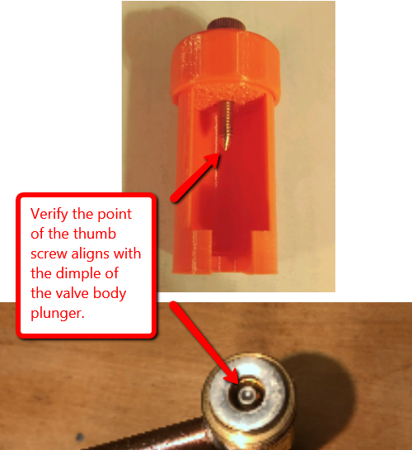

**\* This EEV Block-off Tool should only be used by qualified technicians who have been properly trained for troubleshooting and repairing VRF equipment.**

**VRF Specialty Tools assumes no liability for damage to the equipment, or the tool itself, as a result of improper use of the tool and/or failure to verify normal equipment operation after the tool has been used.**

**Limited Warranty:**

**Thank you for your purchase. All items sold by VRF Specialty Tools are warranted for 1 year from the date shipped. Warranty does not cover obvious physical damage from mishandling or exposure to water.**

**To obtain warranty please fill out the information below and email to** [**bld529.vst@gmail.com**](mailto:bld529.vst@gmail.com)**.**

**Name__________________________________________________**

**Address________________________________________________**

**City, State, Zip___________________________________________**

**Item #_______________________**

**Date Purchased_______________**

**Issue___________________________________________________**

**_______________________________________________________**



**ST-04 Magnetic LEV Tool:**

**Use this tool to manually drive a magnetic (direct acting) LEV stepper motor clockwise or counter clockwise. The tool contains powerful neodymium bar magnets that create a strong magnetic field that can be used to drive the valve’s needle mechanism open or closed.**

**Step 1: Remove the existing magnetic stepper assembly.**

**Step 2: Slide the ST-04 tool over the dome portion of the LEV.**

**Step 3: Rotate the tool CW or CCW. Typically, 8-10 turns of rotation are required to drive the valve full open or closed.**

**Step 4: Verify the valve is feeding, or not feeding, depending on dire3ction valve was driven.**

**Step 5: Upon completion, re-install the magnetic motor assembly and reset the ODU.**

**Step 5: Restart the system and verify valve operation is normal.**

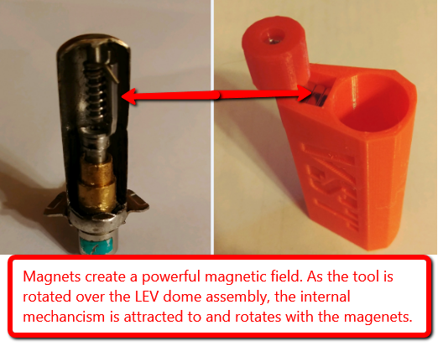

**\* This Magnetic LEV Tool should only be used by qualified technicians who have been properly trained for troubleshooting and repairing VRF equipment.**

**VRF Specialty Tools assumes no liability for damage to the equipment, or the tool itself, as a result of improper use of the tool and/or failure to verify normal equipment operation after the tool has been used.**

**Limited Warranty:**

**Thank you for your purchase. All items sold by VRF Specialty Tools are warranted for 1 year from the date shipped. Warranty does not cover obvious physical damage from mishandling or exposure to water.**

**To obtain warranty please fill out the information below and email to** [**bld529.vst@gmail.com**](mailto:bld529.vst@gmail.com)**.**

**Name__________________________________________________**

**Address________________________________________________**

**City, State, Zip___________________________________________**

**Item #_______________________**

**Date Purchased_______________**

**Issue___________________________________________________**

**_______________________________________________________**



**ST-06 EEV Stem Repair Tool:**

**The ST-06 EEV Stem Repair Tool is used to replace the steel dimple on the top of the EEV valve body plunger (stem) in the event it is broken or damaged. The recess in the steel dimple keeps the shaft of the stepper motor (EEV power assembly) centered on top of the plunger. The ST-06 Tool is for temporary repair only, the EEV valve body will need to be replaced.**

**Step 1: Place the system in the service function mode that drives all EEVs to the fully open position.**

**Step 2: Remove the EEV stepper motor (power assembly).**

**Step 3: Remove all pieces of the broken or damaged steel dimple.**

**Step 4: Slide the repair dimple over the top of the EEV valve body plunger and push down to make sure it is fully inserted.**

**Step 5: Re-install the EEV stepper motor.**

**Step 5: Remove the system from the service mode and reset.**

**Step 6: Restart the system and verify the EEV is operating normally.**

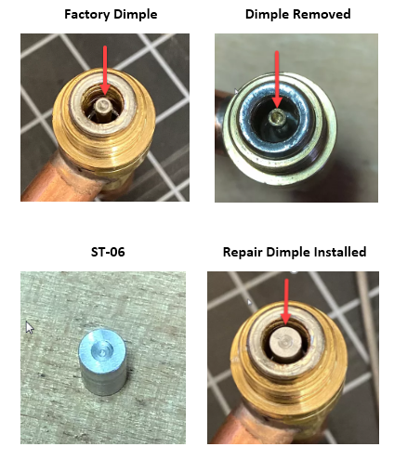

**Reminder: The ST-06 EEV Stem Repair Tool is for temporary use only. The EEV valve body should be replaced as soon as possible.**

**\* This EEV Stem Repair Tool should only be used by qualified technicians who have been properly trained for troubleshooting and repairing VRF equipment.**

**VRF Specialty Tools assumes no liability for damage to the equipment, or the tool itself, as a result of improper use of the tool and/or failure to verify normal equipment operation after the tool has been used.**

**Limited Warranty:**

**Thank you for your purchase. All items sold by VRF Specialty Tools are warranted for 1 year from the date shipped. Warranty does not cover obvious physical damage from mishandling or exposure to water.**

**To obtain warranty please fill out the information below and email to** [**bld529.vst@gmail.com**](mailto:bld529.vst@gmail.com)**.**

**Name__________________________________________________**

**Address________________________________________________**

**City, State, Zip___________________________________________**

**Item #_______________________**

**Date Purchased_______________**

**Issue___________________________________________________**

**_______________________________________________________**